**GROUP NO. 20**

**MEMBERS :**

SANJANA ASRANI 01

SAKSHI BHOJWANI 09

VARAD DESHMUKH 19

*DBMS GROUP MINIPROJECT*

TOPIC : **HOSTEL MANAGEMENT SYSTEM**

**PROBLEM STATEMENT** :

The aim of Hostel Management System is to carry out management related tasks for students,rooms ,mess and visitors in a systematic and reliable manner.

* The university is organized into departments. Each department has staff along with a unique id. Each staff has a role-name like mess employees , security , warden , Administrator etc. All this staff manages and looks after the rooms.
* There are wardens , janitors , mess employees that work for and in the hostel. The staff’s name , mobile number , their designation along-with their salary are recorded and each staff is identified by its unique id .
* Students stay in the rooms managed by staff. Each student in the hostel has a name , unique id , fee status , staying period , aadhar card number and his/her age , department associated with it.It also has information of the room that it is alloted. The students have visitors visiting them during their stay in the hostel.
* Each room is identified by a unique room id and a room number . It is maintained by keeping a room occupancy/vacancy list of students currently staying in them, to see if it has space for more students . It is possible that more than 1 student live in a room . But one student cannot have more than 1 room. Furthermore , it keeps tract of the monthly bills .
* A student can have visitors hence a unique visitor id , visitor’s name and the exact time of their visit is something to be kept in track of . A visitor can visit a student multiple times .

**ERD FOR HOSTEL MANAGEMENT SYSTEM :**

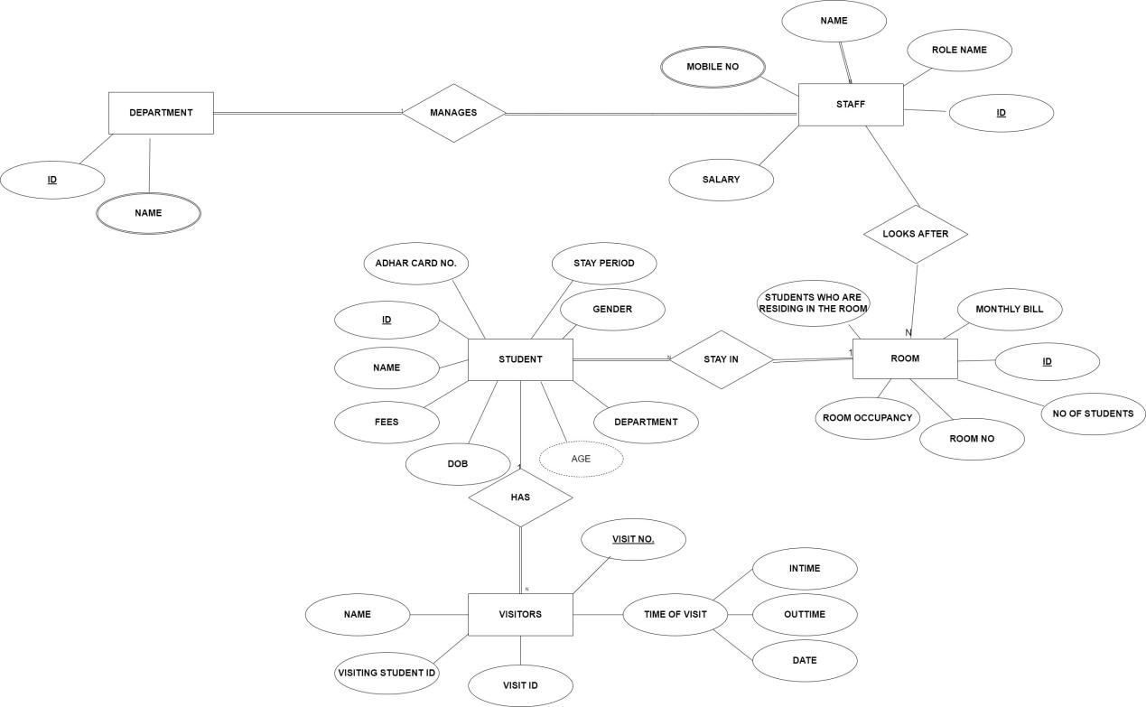

**DETAILS ABOUT THE ENTITIES AND THE ATTRIBUTES INVOLVED :**

Entities(HOSTEL SYSTEM):

1. **Department**:

Each department has a unique id and a department name. Every department has some staff like mess incharge , administrator that manage the hostel.

1. **Staff** :

Staff_id is the primary key here. Each staff will have a role-name to explain the work it is assigned. It also has a mobile number.

Mobile number again is a multi-valued attribute .

1. **Student** :

Student_id is the primary key which is also a foreign key for Room since room is a weak entity.

Age is a derived attribute since date of birth is already there.

1. **Room** :

Primary key of room is room_id. It has attributes like no. Of students residing in it to keep track of condition of rooms.

1. **Visitor** :

Primary key of the Visitor’s table will be visit_number. Since there can be multiple records/entries for the same visitor.

( Primary keys , Partial keys , Derived attributes )

|  |  |
| --- | --- |
| ENTITIES | ATTRIBUTES |
| DEPARTMENT | * Id * Name |
| STAFF | * Id * Role-name * Name * Mobile no * Salary |
| STUDENT | * Id * Name * Date of birth * Age * Gender * Aadhar card number * Stay period * Fee status * Room id assigned to him/her |
| VISITOR | * Visitor entry number * Id * Name * Date * In time * Out time * Visiting_student_id |
| ROOM | * Room Id * Room No * Number of students * Room occupancy * Monthly bills * Students who are residing in them |

**BASIC TABLE STRUCTURE OF HOSTEL MANAGEMENT**

**ER(ENTITY RELATIONSHIP) DIAGRAM :**

**DEPARTMENT**

|  |  |
| --- | --- |
| department_id | admin_name |

**STAFF**

|  |  |  |  |  |
| --- | --- | --- | --- | --- |
| staff_id | staff_name | staff_contact_no | staff_salary | Staff_role_name |

**STUDENT**

|  |  |  |  |  |  |  |  |  |
| --- | --- | --- | --- | --- | --- | --- | --- | --- |
| stud_  id | stud_  name | stud_aadhar_no | stud_stay_  period | stud_  gender | stud_  dept | stud_  dob | Fee_  status | Alloted_  room_id |

**VISITOR**

|  |  |  |  |  |  |
| --- | --- | --- | --- | --- | --- |
| visit_no | visitor_id | Visitor_name | in_time | out_time | date |

**ROOM**

|  |  |  |  |  |  |
| --- | --- | --- | --- | --- | --- |
| room_id | room_no | num_of_stud | room_occupancy | monthly_bills | id_of_students_in_them |